**DRAFT**

**Town of Cape Elizabeth, Maine**

**Municipal Downtown TIF District Application**

**Town Center Tax Increment Financing District**

**Municipal Infrastructure Improvement Program**

Approved by the Cape Elizabeth Town Council

at a Public Meeting

Month date, 2014

DATE

Laura Santini-Smith

Tax Incentives Program Director

Maine Department of Economic and Community Development

111 Sewall Street, 3rd Floor

59 State House Station

Augusta, Maine 04333-0059

Re: Town of Cape Elizabeth Town Center TIF District

Dear Smitty:

In accordance with Chapter 206 of Title 30-A of the Maine Revised Statutes, as amended, enclosed please find the application of the Town of Cape Elizabeth for a Town Center TIF District. This application was approved by the Cape Elizabeth Town Council at the DATE, 2014 meeting.

I certify that all information contained in this application is true and correct to the best of my knowledge.

Thank you for your guidance is preparing this application and please feel free to let me know if there is any additional information you require.

Sincerely,

Michael K. McGovern

Town Manager

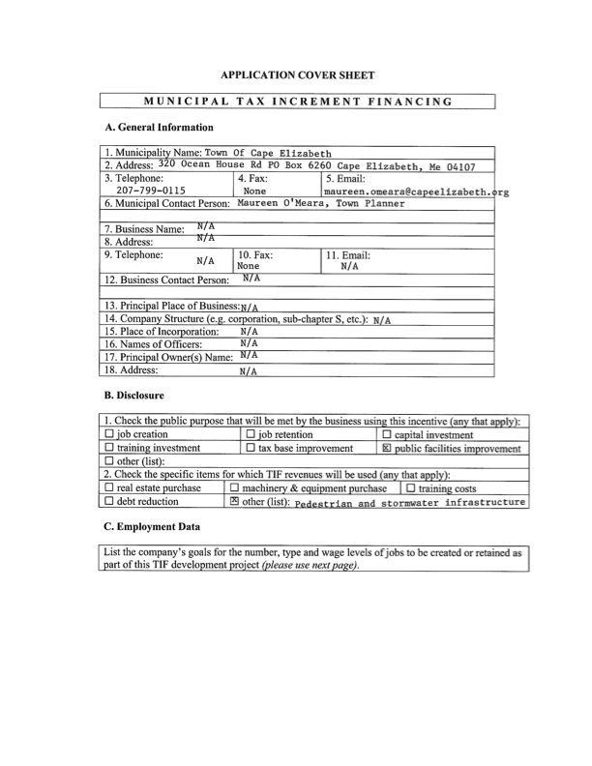

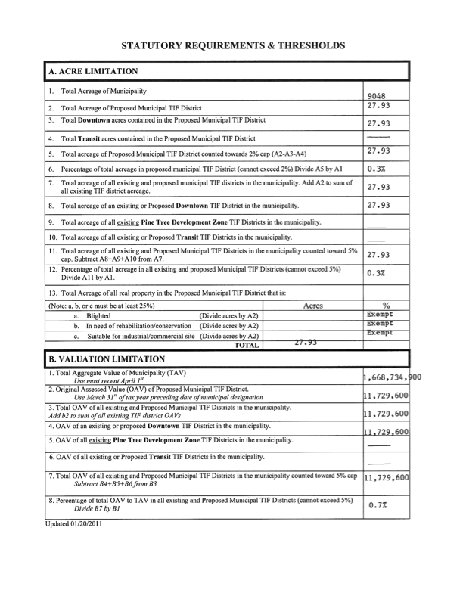

**Introduction**

In 1993, the Town of Cape Elizabeth Town Council adopted a Town Center Plan. The plan laid out a vision for a Town Center, including a new zoning district adopted in 1995, and a pedestrian friendly environment that was formally recognized as the town's central business district, municipal and cultural center.

Twenty years later, a new Town Center Plan committee was appointed by the Town Council to update the plan. Overall, the 2014 Town Center Plan continues the direction established in 1993, but also offers a sharper focus on the needs of the town center going forward. The 2014 plan includes only 7 recommendations. In particular, the plan recognizes the town's inability to fully realize the 1993 pedestrian-friendly infrastructure recommendations. The Town Center zoning district requires new development to build sidewalk along its frontage and the town has made over $500,000 in sidewalk improvements, however, the town center sidewalk network remains incomplete. Public comment has consistently supported an interconnected sidewalk network. Further, it has become apparent that the modest town center stormwater infrastructure should be modernized and expanded.

For these reasons, the plan includes a recommendation to establish a Town Center TIF District for the purpose of completing the sidewalk network, potentially expanding the sidewalk network to adjacent neighborhoods, and improving stormwater infrastructure. TIF funds will be used for municipal infrastructure improvements.

**5. The Development Program - State of means and objectives**

To implement the public infrastructure recommendations in the Town Center Plan (See Attachment A), the Town of Cape Elizabeth is designating properties within the town center as a Tax Increment Financing (TIF) District, pursuant to Chapter 206 of Title 30-A of the Maine Revised Statutes, as amended. A twenty (20) year TIF program is proposed.

The TIF district encompasses approximately 27.93 acres. This area represents the central business district, and includes the school campus, a concentration of municipal uses and the largest number of commercial establishments in town. The Town Center TIF district will support community development objectives by:

•Realizing the town center vision "to create an identifiable, vibrant town center that includes mixed retail uses for residents and visitors, a safe and inviting pedestrian and bicycle environment, a common meeting place, visual vitality, and linkages to the town's open space and nearby residential neighborhoods;"

•Constructing and improving public pedestrian facilities and stormwater infrastructure.

•Positioning the town to quickly respond to possible grant funding opportunities;

•Stimulating private reinvestment in existing town center zoned properties by improving the adjacent public infrastructure; and

•Improving the appeal and draw of the town center to support existing commercial businesses.

a. Description of Public Facilities and Programs

The Town Center TIF district is proposed to fund improvements described in the following recommendations in the 2014 Town Center Plan.

**Goal: Pedestrian and Vehicular Circulation**

**1.** Improve and expand pedestrian and bicycle safety and connectivity of sidewalks and paths within the Town Center and to nearby neighborhoods.

Background: In the late 1990’s, the Town obtained grant funding to build and rebuild sidewalks from Scott Dyer Rd/Longfellow Drive to the Pond Cove Shopping Center on Route 77. Additional sidewalk construction has occurred in the Town Center and the Shore Road Path was constructed in 2011. (See Appendix F for more information on existing and proposed sidewalks.)

Recommendation Description: This recommendation would complete the sidewalk network throughout the Town Center. Additional sidewalk connections to nearby neighborhoods would also be pursued. Less formal paths within the Town Center, including greenbelt connections to Robinson Woods and the Spurwink Marsh, and a path from Route 77 to the library, would be evaluated, constructed, improved and/or maintained. Pedestrian safety in the Town Center is a priority, including at the Route 77/Shore Rd/Scott Dyer Rd intersection. Preservation of existing biking infrastructure and expansion of biking infrastructure when appropriate should also be considered.

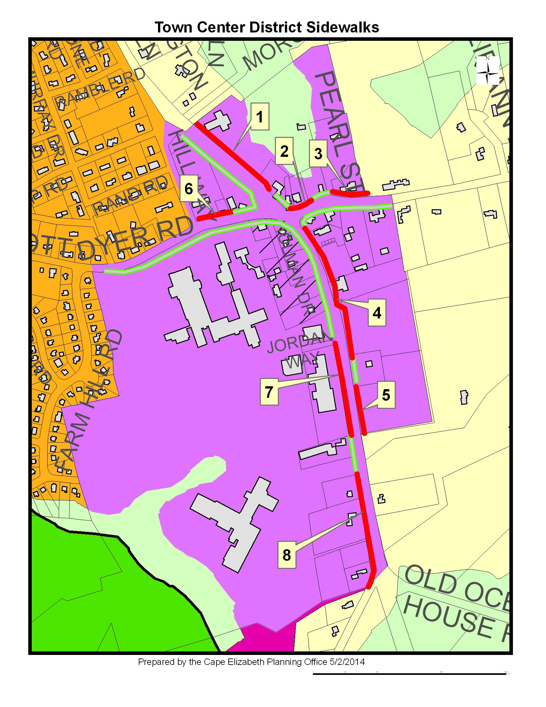

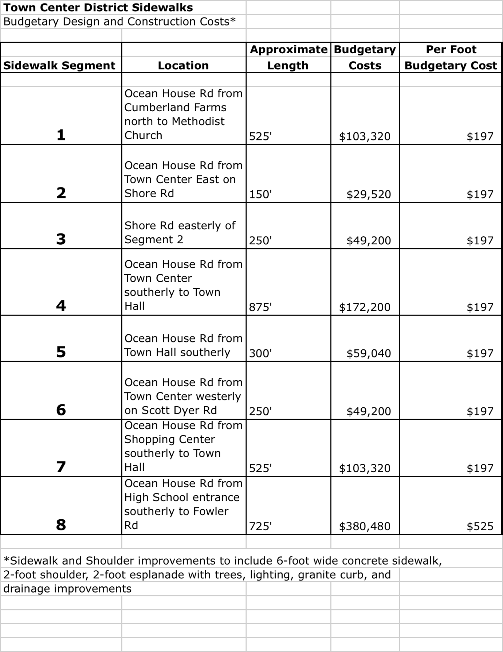

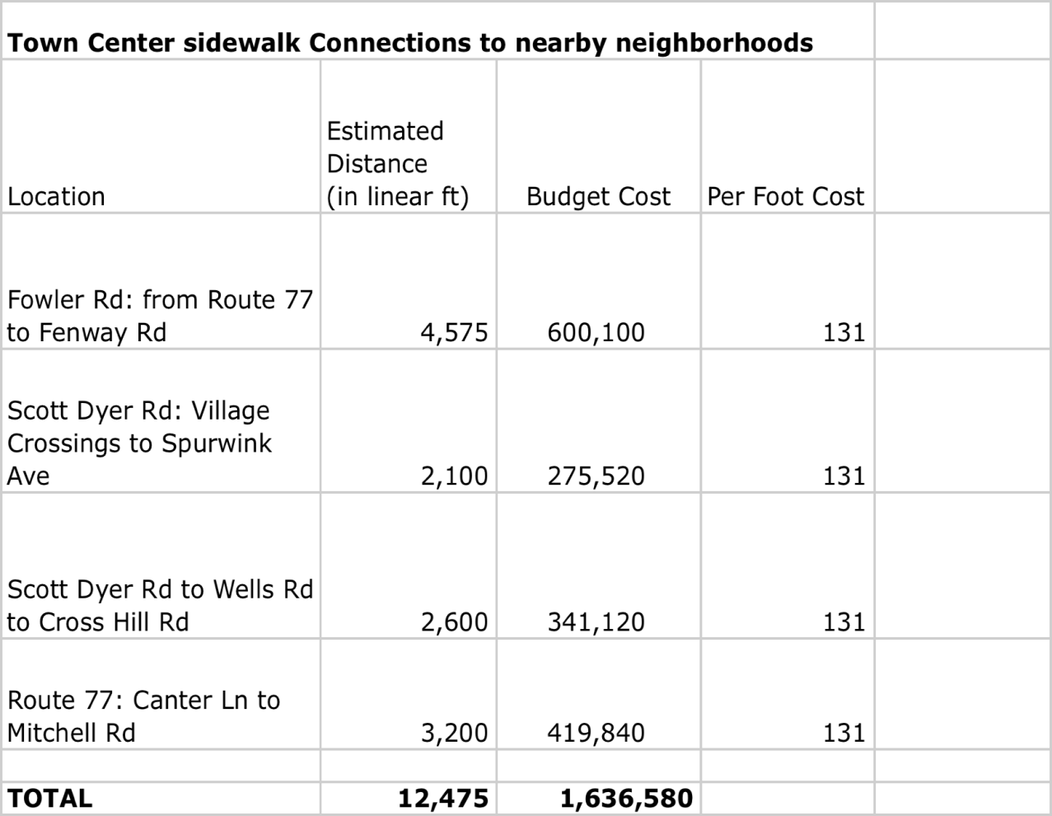**Goal: Primary Commercial Area**

**3.** Update the Town Center Stormwater Management Study and plan for construction of needed stormwater improvements.

Recommendation Description: The 1995 plan should be reviewed and updated, both with improvements already constructed and with integration of Low Impact Development (LID) techniques as appropriate. The study should be prepared by a professional engineer working with town staff. Seventy-five percent of the 1995 study was funded with a grant and town staff should be directed to pursue grant funding for the update.

The Town has received grant funding for the study, so TIF funds would be limited to design/construction of stormwater facilities consistent with the new stormwater plan.

**Goal: Infrastructure financing**

**7.** Develop funding strategies, including but not limited to a Tax Increment Financing (TIF) District for the Town Center, to fund infrastructure improvements.

Background: The 1993 Town Center Plan included recommendations for construction of sidewalks throughout the Town Center, creation of a village green, a stormwater management system, and other improvements. Most of these improvements have not been completed due to a lack of funding. Some sidewalk connections and stormwater improvements were designed but not built due to a lack of construction funding. Many of these same improvements are now recommended as part of this Town Center Plan, but the outlook for municipal funding at this time remains the same.

b. Description of commercial facilities, arts districts, improvements or projects to be financed

Non-municipal improvements are not proposed to be financed by the Town Center TIF District proceeds.

c. Duration of the Program

The duration of the Town Center TIF District is proposed to be 20 years.

d. Certification of original assessed value of the taxable property in the TIF district by the municipal tax assessor, using valuation from the prior March 31st.

Matthew Sturgis, Municipal Tax Assessor for the Town of Cape Elizabeth, certifies the original assessed value of the taxable property in the Town Center to be $11,729,600.

e. Physical description of the district

Below is a map showing the boundaries of Cape Elizabeth and the location of the Town Center zoning district.

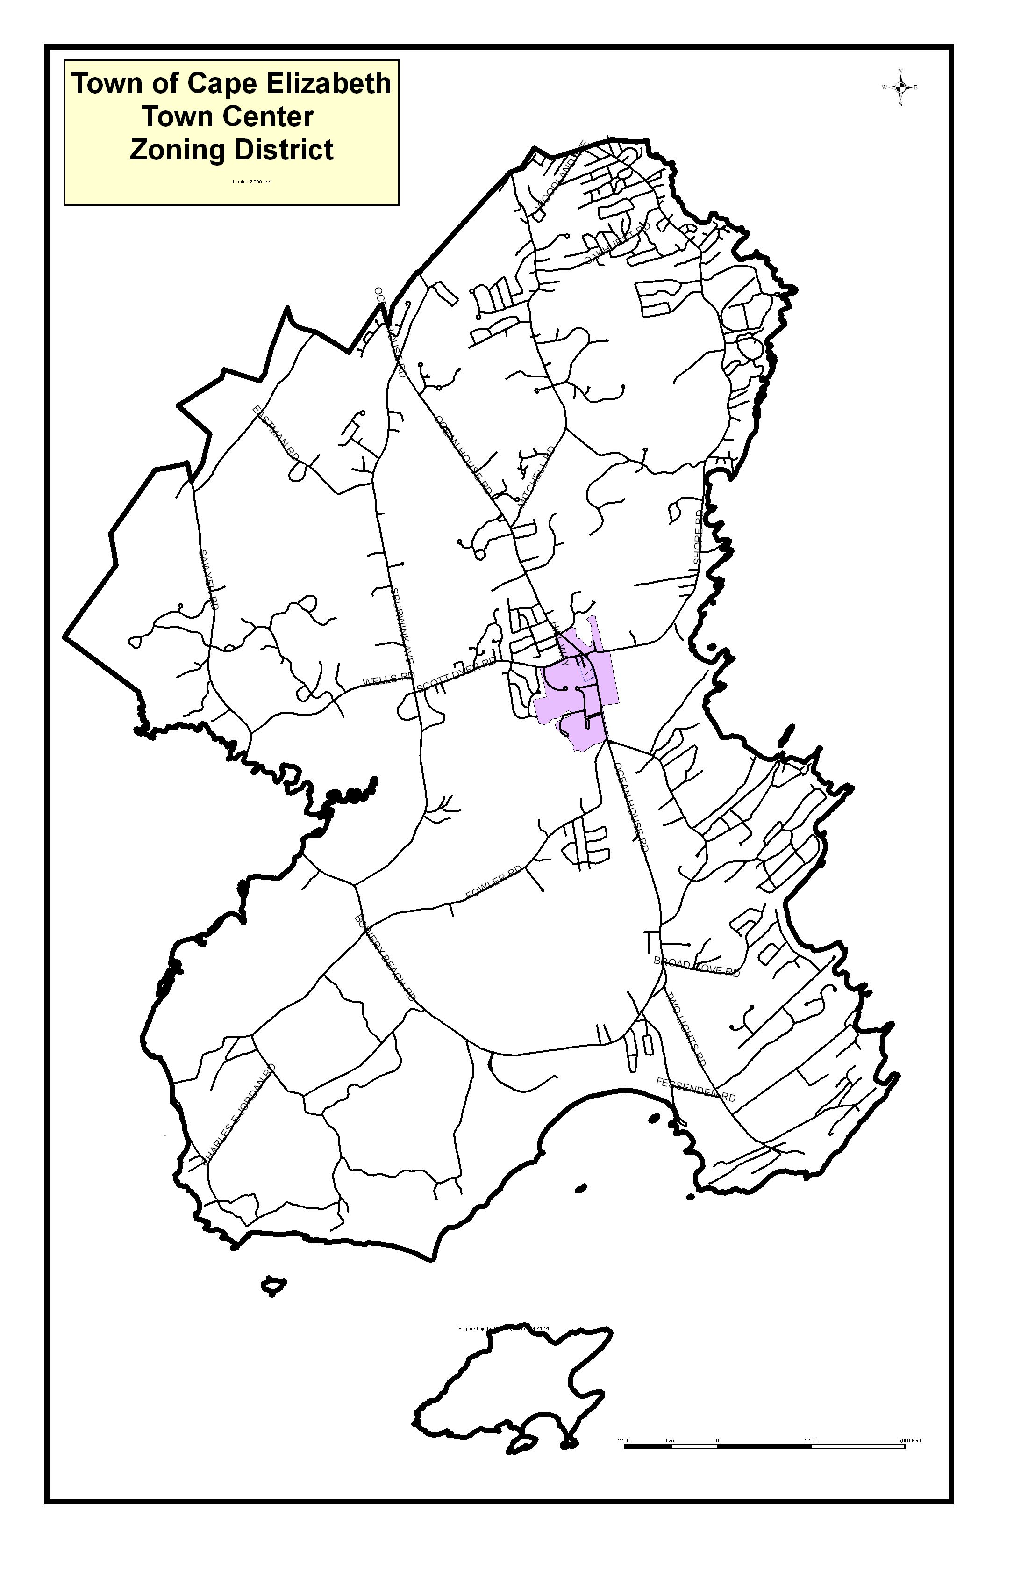

Below is a map of the Town Center zoning district (shown in purple), which is proposed to be the Town Center TIF District:

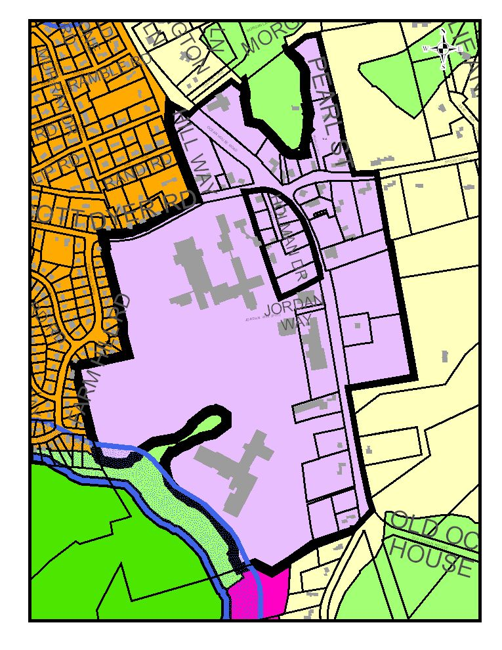

f. Financial Plan

i. Cost estimates for the development program

Estimated cost to complete the sidewalk network within the town center is $946,280 dollars. Estimated cost to extend sidewalks from the town center to nearby neighborhoods is $1,636,580 dollars. The town has received a grant to update the stormwater plan and that update will include stormwater infrastructure cost estimates. Sidewalk construction costs alone far exceed anticipated TIF revenues.

ii. Amount of public indebtedness to be incurred.

No public indebtedness is proposed at this time. The intention of the Town of Cape Elizabeth is to allow TIF revenues to accrue in a segregated account until a public infrastructure project can be funded. The town expects that TIF funds will be supplemented with general revenues, grants, donations and other funding dependent on the infrastructure project to be constructed.

iii. Sources of anticipated revenues

Infrastructure improvement project funding will vary, but is expected to be a combination of general revenues, grants, and donations.

iv. Description of the terms/conditions of any agreements

No credit enhancement agreement (CEA) is proposed as part of this TIF.

v. Estimates of increased assessed values of the district for each year of the program.

See Table 1. The town is estimating 4 million dollars in increased property value in the town center over the next 20 years. The estimate is based on past experience with values in the town center and the amount of property in the town center currently in transition.

vi. Portion of the increased assessed values to be applied to the development program as captured assessed values and resulting tax increments in each year of the program.

One hundred percent of the increased assessed values is proposed to be applied to the development program. See Table 1.

vii. Tax shift calculations for each year of the program.

See Table 2. The estimated tax shift is $2,000 annually.

g. Plans for the relocation of persons displaced by the development activities

Not applicable. No displacement of persons will be required to construct public infrastructure improvements.

h. Proposed regulations and facilities to improve transportation

No new regulations are proposed. Any improvements considered in the TIF district within the right-of-way of Route 77 will be subject to review by the Maine Department of Transportation. Improvements considered in the TIF district within the right-of-way of other roads will be reviewed for compliance with town road and pedestrian improvement standards. Improvements will accommodate anticipated vehicular, bicycle and pedestrian traffic in the TIF district.

i. Environmental Controls

Any improvements proposed in the Development Program will comply with all federal, state and local rules and regulations and applicable land use requirements.

j. Operation of the Town Center TIF District after the infrastructure improvements are completed

Improvements in the TIF District within the public way will at all times be owned by the Town of Cape Elizabeth, or its successors or assigns, which will be responsible for all maintenance of said improvements. During the duration of the TIF District, the town manager or his/her designee will be responsible for all administrative matters concerning the implementation and operation of the TIF District.

**6. Evidence of Public Hearing**

a. 10 day notice of public hearing, including proof of date of publication

INSERT COPY OF PUBLIC HEARING AD WITH DATE

b. Minutes of public hearing, attested to and signed

INSERT COPY OF PUBLIC HEARING MINUTES

c. Record of district designation by municipal legislative body

The Cape Elizabeth Town Council authorized designation of the Town Center TIF district as the DATE meeting, the minutes of which are attached under subsection b above.

**ATTACHMENT A**

**2014 Town Center Plan**

